Practical 1

Steps to configure DHCP Server configure NFS Server to share on your network configure NFS client(Ubuntu and Windows)

**Step 1:** In your Ubuntu open a terminal and input the following command to install DHCP server.

sudo apt-get install isc-dhcp-server

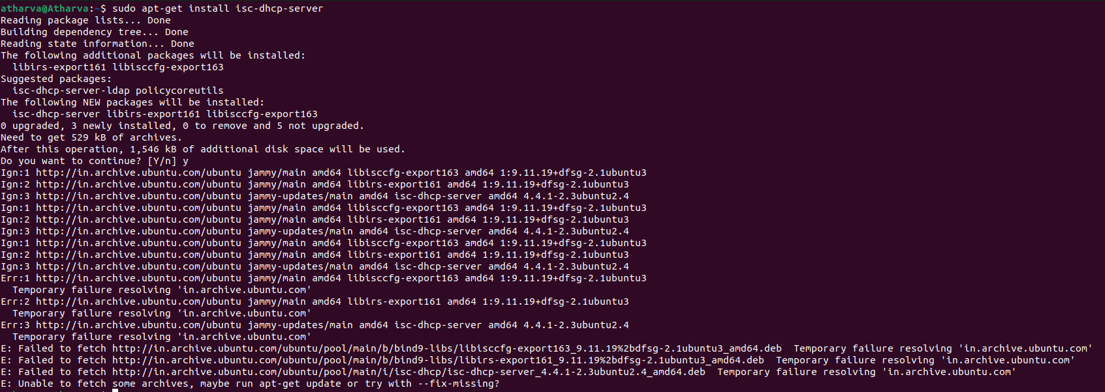

**Step 2:** Once the installation has been done make sure the network settings of your virtual machine is set to bridged network.

**Step 3:** In terminal type in ifconfig to verify as to whether an IP address has been assigned to your virtual machine.

Ifconfig

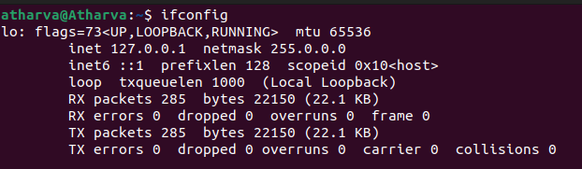

**Step 4:** Next we need to configure our installed dhcp server to it serve ip address to connecting clients. Follow the following configuration.

sudo nano /etc/dhcp/dhcpd.conf

**Step 5:** Look for the section which says “A slightly different configuration for internal subnet.”

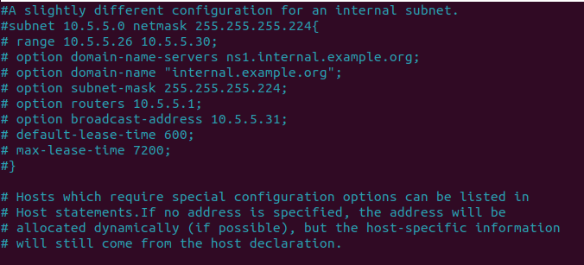

**Step 6:** Now start by configuring the subnet line. Set the first IP address the start of your network range(The IP address you received in the output of ifconfig be used to calculate it. Here the ip address was 192.168.0.10).

**Step 7:** Set the net mask to 255.255.255.0 (this can be done by pressing ctrl+\, which will open a replace prompt where you will have to type the original net mask which here was 255.255.255.224 and press enter the it will ask what it should be replaced with, then type 255.255.255.0, then press enter.)

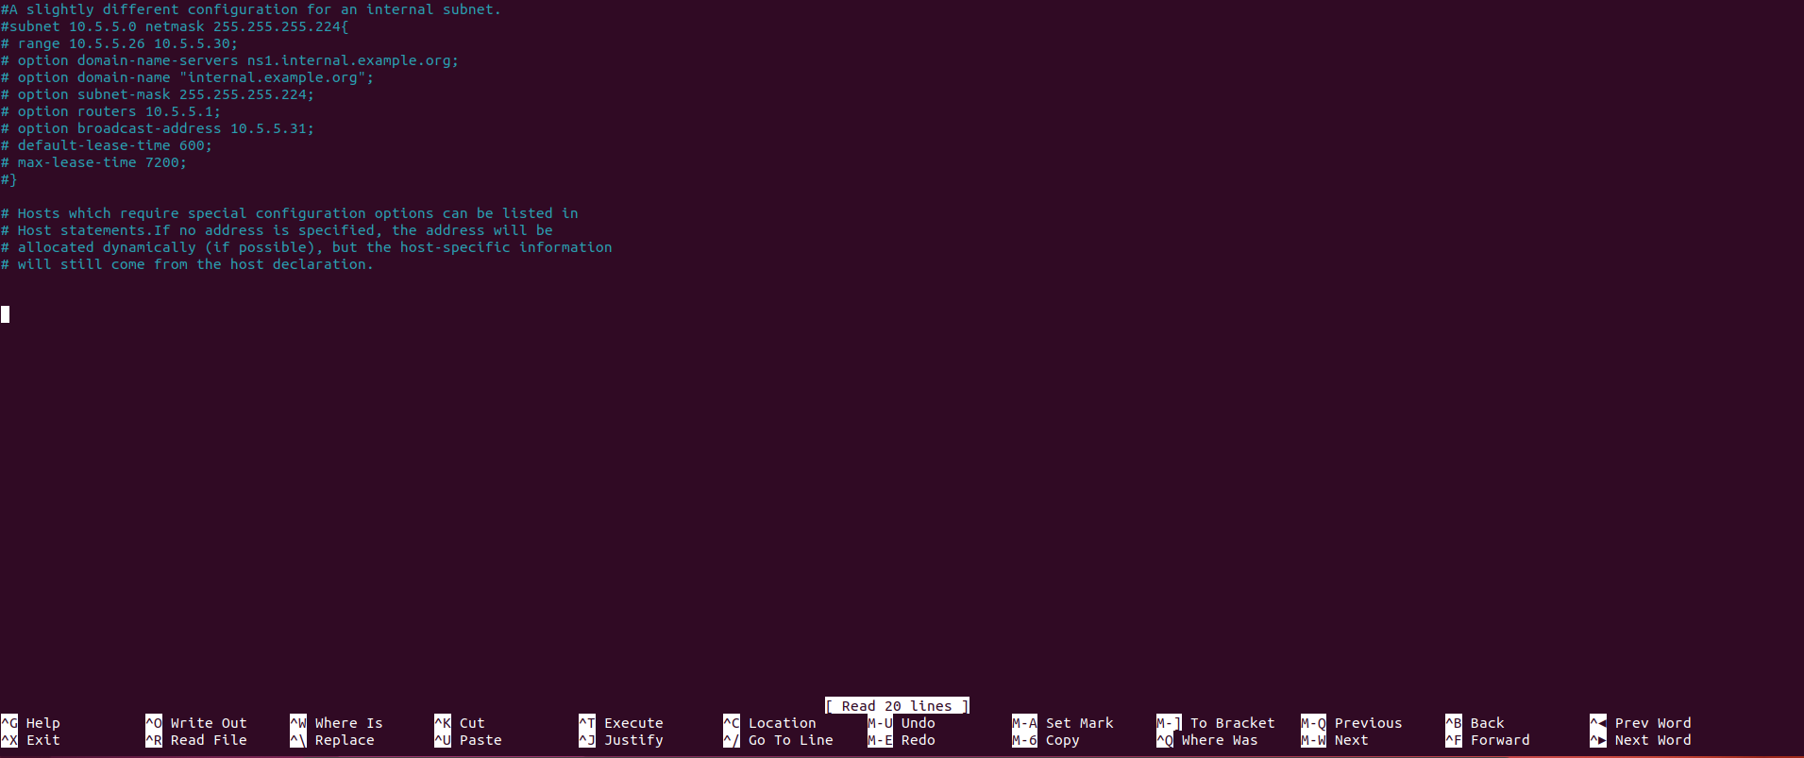

**Step 8:** In range set a range of IP address you would like your server to serve. Here it is set to server 20 addresses ranging from 10.5.5.10 to 10.5.5.30(For changing the range do the same by replacing whole range section by typing “range 10.5.5.10 10.5.5.30 in replace it with prompt.”)

Note: The range for me was 10.5.5.26 10.5.5.30 for your pc/system it might be different so change accordingly.



**Step 9:** Configure the routes line to be the default gateway.

**Step 10:** Save this file by exiting it “ctrl+x”, then in the prompt enter y and press enter or just press enter.

**Step 11:** Now we have installed and configured our DHCP server. Let’s start our DHCP server by using the following command.

Sudo /etc/init.d/isc-dhcp-server start

**Step 12:** To cross verify that the ip address is actually served from the dhcp server go back to Ubuntu where the dhcp server has been configured and type in

cat var/lib/dhcp/dhcpd.leases

**Step 13:** The ip address received at the client will be the same as listed in the output received by above command.